*AUDIO VISUALIZER ASSIGNMENT*

Group: Kellie Meagher, Joelle Tierney, Olaywiola Balinga

Git Repository: <https://github.com/Spakelios/VisualDesignIsOurPassion>

Youtube Video: https://youtu.be/e5pdY5B4Wgc

***Songs:***

* *Vaporwave - Hong Kong Express*
* *Blank Banshee B Hidden Reality*

***What does the project do? :***

* *It is a visual art piece that reacts to sound with interactive elements.*

***What are the controls?:***

* *Change screens using the number keys 1-5, while using a drawing tablet to draw freehand on the “2” screen.*

***How to make it run?***

*-        Run sketch*

***What each person did and what they’re most proud of :***

***KELLIE:***

I Started by testing arrays reacting to sound ,as well as having it be multicoloured with simple and more complex objects, using map/arrays/pshape/classes/minim. Also I began incorporating 3d shapes such as spheres and cubes. I went on to use a for loop and an array to create a visual effect of lines forming almost a road like path and circles above with react to the music and bob in time with it. Also made freehand writing react to music also. Then I began looking into inheritance and polymorphism.

 Inheritance worked well to an extent leading to a pacman-esc shape spinning around, as well as a circle array in the background for some extra visual flair. Polymorphism was less successful, being a lot harder to use and not really fitting in with the overall visual style of the project. The part I’m most proud of is the “rainbow road” screen as it was quite difficult to get a more contained reaction to the song. I think it turned out very well.

***Attempts / Visuals:***

[they do be vibing.mp4](https://drive.google.com/file/d/1xsmt4l__1dk4E760e23uU0usjASi19SV/view)

***JO:***

I found the original code for drawing freehand in Processing. I also found code for clearing a canvas/screen after pressing a button/mouse click, although it wasn’t incorporated into the final project.I also created a heart sketch using points and the pow function, which I then made react to the music; this gave the heart a shimmery sort of effect, as the dots vibrated to the music. The original heart drawing was in a class, however I had to scrap the class when I made it react to music, as it seemed to interfere with the reactivity. By using an array, I also added numerous stars to the screen which cycled between a multitude of colours at random. I started messing around with the shooting ship code to see if I could get the bullets to react to the sound. This was successful, however only the ends of the bullets were multicoloured and as such the screen was not visually appealing, so it remained unused. I polished the code of the 3D spheres reacting to the sound made by Kellie by changing the size of the background spheres and fixing the frame rate. Finally, I made the text that appears at the start of the program somewhat more readable while it reacts to the music and changes colours; the text duplicates itself as it reacts to the music, however I believe this fits with the vapourwave style we were going for.. The part I’m most proud of is the “Rainbow Heart” screen, as I think the shimmery effect the dots give it while it reacts to the music is aesthetically pleasing.

***ATTEMPTS /VISUALS:***

                                                              Before Clear                                After Clear

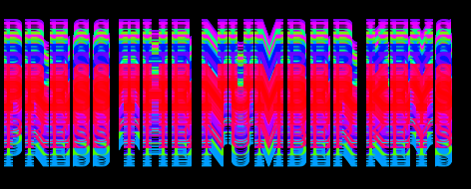

***OLAY***

Made code optimisations from the previous Codes. Made the number keys map to the drawing and audio visualiser screens. Also increased the stroke of the drawing to 6. Added an audio visualiser line that lerps to the screen. Fixed the key screen to : “Press The Number Keys”. I would frequently check with the other’s code such as music segments and all of the screens. I also downloaded the music we would be using for the project. Although some of the problems were a bit hard I still managed to find solutions to them which made me and the others feel like the project was do - able. I also managed to make the audio switch between two different songs on certain screens allowing us to finally do multiple musics and allow for better visuals on certain screens.

If I were to go back there’s not much I would change about the project, everything kind of went how we expected it and I am happy with how it turned out to be.

I am not proud of any one screen. I'm proud of how we were able to link the screens together allowing it to be one processing file through a button press.

***ATTEMPTS/VISUALS:***

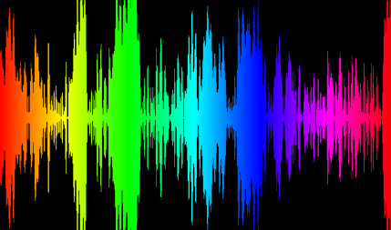 - Reacted to the new sound from the other project through minim sound switching.

- made the title screen react to the beginning sound too from the other project.